AWS Task-4

Task Description:

Launch an EC2 instance (Linux and Windows) along with a web server. Then, create an EBS volume of 5 GB, attach it to an EC2 machine (Linux and Windows), and take a snapshot. Finally, create an EBS volume using the taken snapshot.

Launched an EC2 instance

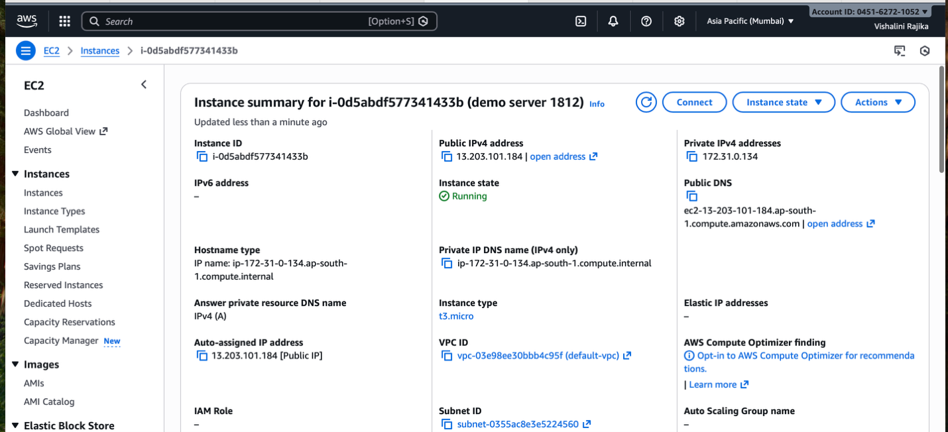

Created EBS volume of 5gb and attached it to the server
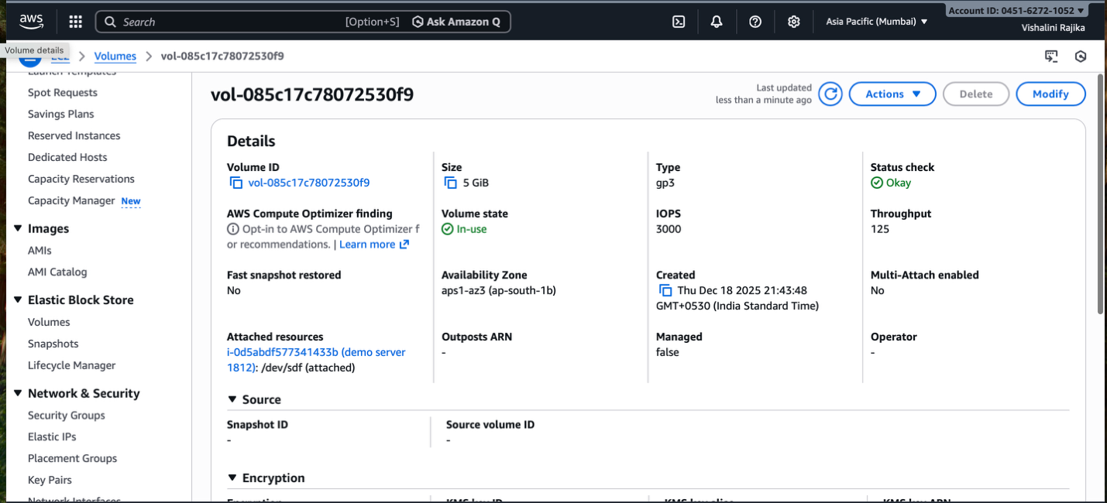

Snapshot taken for the volume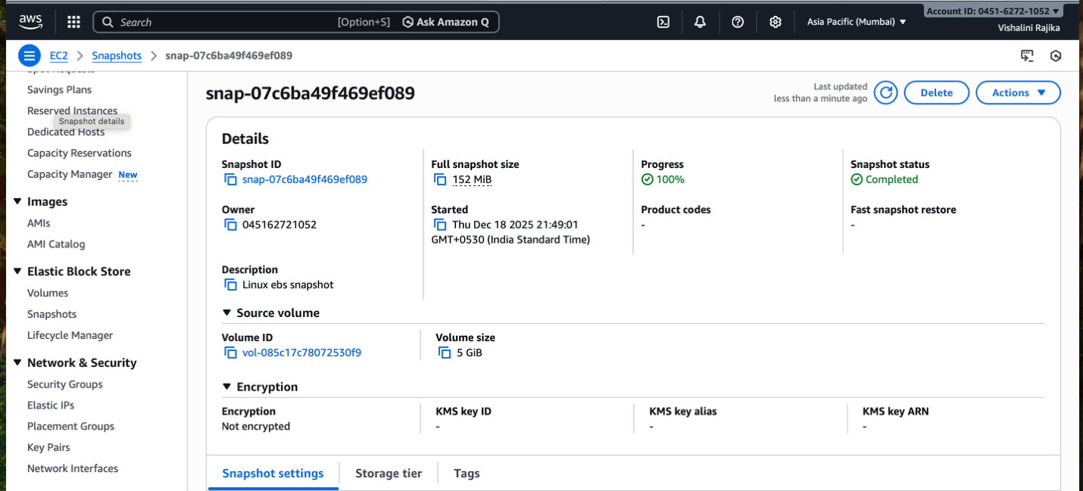

Created the EBS using the snapshot taken
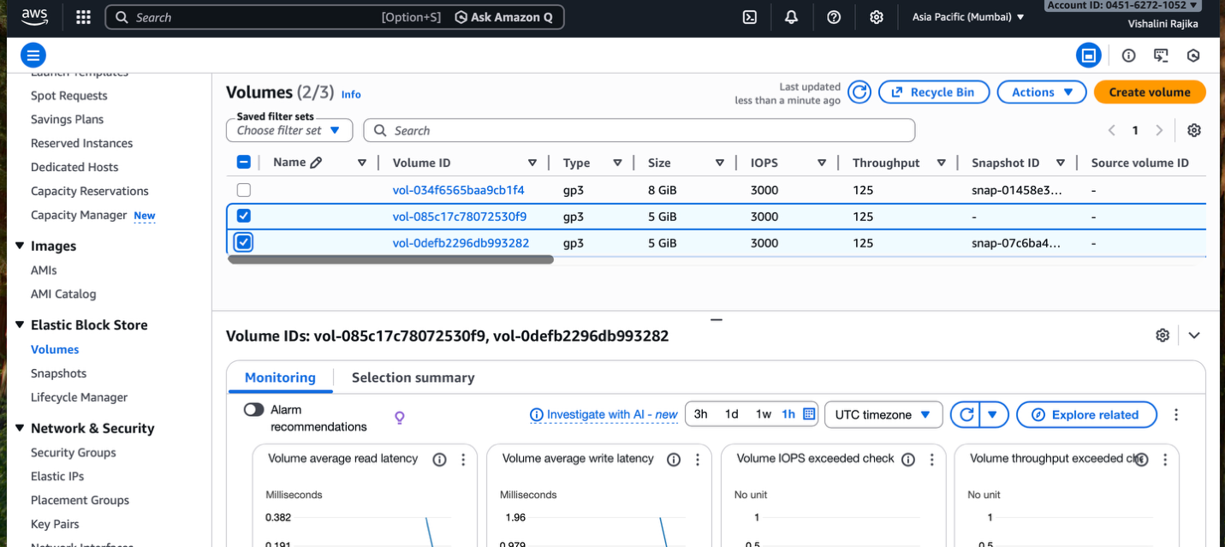
Launched an EC2 windows instance
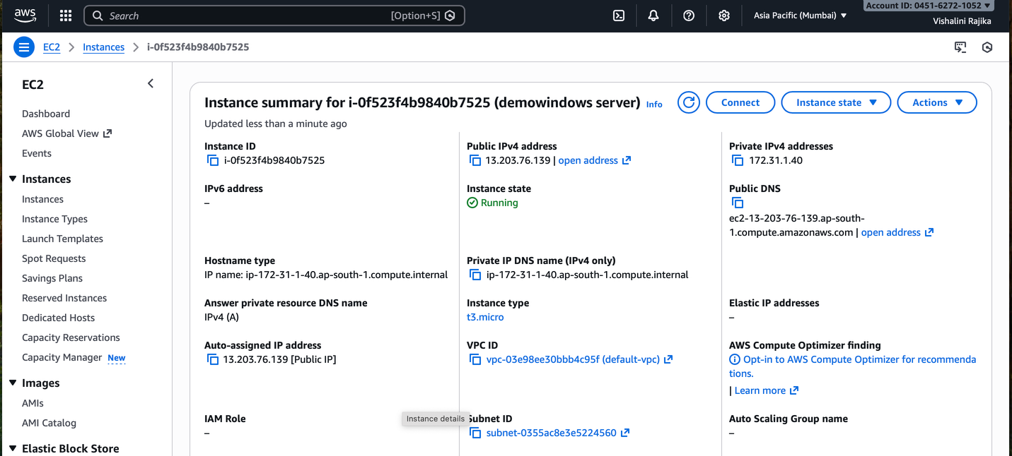

Connected with the instance created EBS volume of 5Gb and connected to the instance.
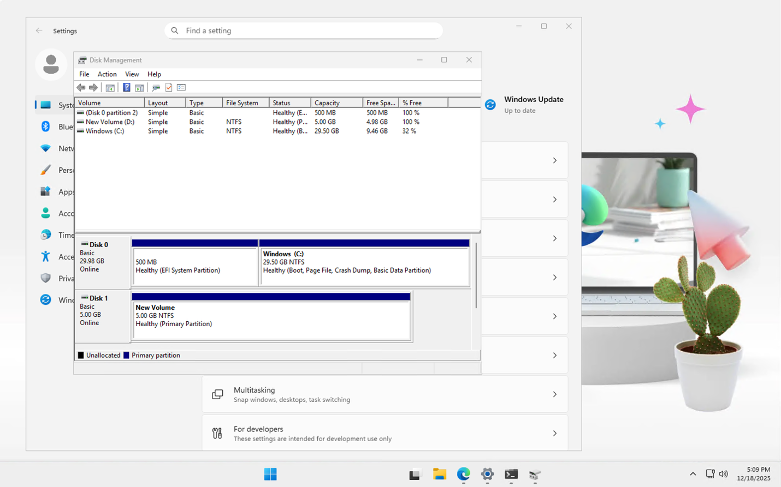
Snapshot taken for the volume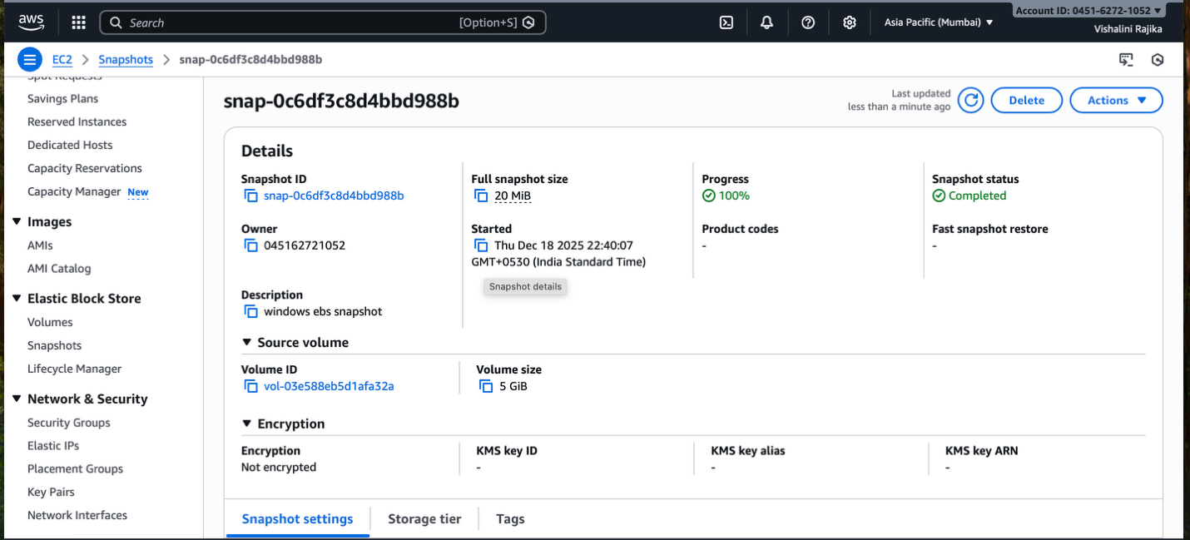

Created the EBS using the snapshot taken
